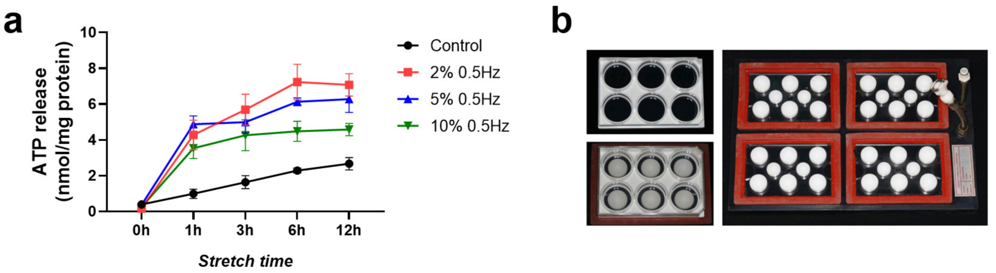
Supplementary Fig. 1. (a) Gradient intervention pre-experiments of load condition. All data are shown as mean ± SD. (b) Schematic of 6‐well flexible silicone rubber plates and mechanical stretching bioreactors (top view).

Supplementary Table 1. Primer sequences.
Gene | Forward primer sequence (5′-3′) | Reverse primer sequence (5′-3′)
Piezo1 | TCATCATCCTTAACCACATGGTG | TGAAGACGATAGCTGTCATCCA
Piezo2 | GTGGTATGCAACCCAGTACCC | GGCCATTCTCTATGGGCAGG
Kcnk2 | CCGAGGCTCTCATTCTCCTCA | AGGACGACCACCAGGAAAATC
Kcnk4 | ATCTGGGGCTCTAGTGTTCCA | CCAAGCTGATGAGTGGTTGCT
Kcnk10 | TGGCTGCATCGTGTTTGTGA | CTGTGGTCAGCGTGACTACC
Stoml3 | GATTCACCGGAGAAACTGGAG | TCCATACTGAGATTGGGAAGGT
TRPA1 | GTCCAGGGCGTTGTCTATCG | CGTGATGCAGAGGACAGAGAT
TRPV4 | ATGGCAGATCCTGGTGATGG | GGAACTTCATACGCAGGTTTGG
Polr2a | CTGGACCTACCGGCATGTTC | GTCATCCCGCTCCCAACAC
Runx2 | AACGATCTGAGATTTGTGGGC | CCTGCGTGGGATTTCTTGGTT
OPN(spp1) | AGCAAGAAACTCTTCCAAGCAA | GTGAGATTCGTCAGATTCATCCG
GAPDH | AGGTCGGTGTGAACGGATTTG | TGTAGACCATGTAGTTGAGGTCA

